Python String strip() and Python String count() with EXAMPLES

# String strip()

While working with strings there can be whitespaces in it. Being a programmer you should be familiar with how to remove the whitespaces in the string. Working with large data sets it helps a lot a save time.

Let’s see how the strip function works.

|  |
| --- |
| str = " Hello World " print(str) print(str.strip()) |

The output will be following.

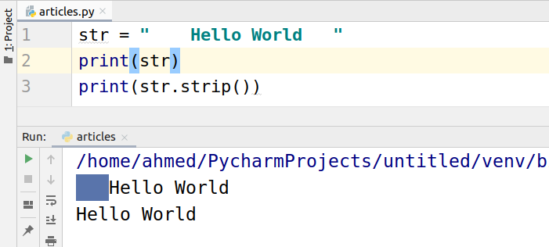

We can also pass an argument to the strip function.

str.strip(characters) # A set of characters to remove as leading/trailing characters

Let’s have a look at the example. We passed “H” and it removed “H” from the string.

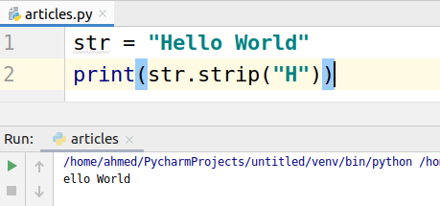

We can also remove the dots and commas.

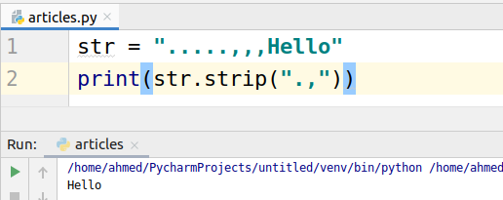

# String count()

Count function is used to find out the occurrence of specific substring.

Let’s learn this by example. If you have this string “Hello I am here. Here I am”

|  |
| --- |
| str = "Hello I am Here.Here I am" print(str.count('Hello')) print(str.count('am')) |

The following will be the output.

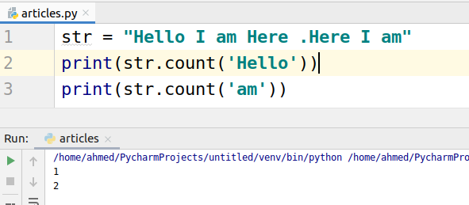

We can also pass the starting and ending points for search. For example, we want to skip the first 7 characters in the string.

As you can see the “Hello” was not found when we tried to search the by skipping first 7 characters.

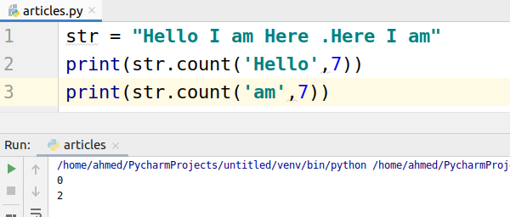

We can also specify the ending point of the search.

As you can see there comes only one “Here” between 7 and 15.

